Crosswalk
Safety
Design Ideas
Submit a sketch of an
earth tone repeating
geometric pattern!

Help us emphasize existing crosswalks in downtown Sitka to improve pedestrian safety.

Ideas will be juried by committee. Selections will be refined and painted later this summer as weather, funds, and labor allows. This is a safety demo project; implementation is temporary. No limit on entries per person.

Community Showcase and
selection announcement
Thursday, June 25th 6:00 pm
Room 3, Harrigan Centennial Hall
Return entry sheets by Wednesday, June 24th by 5:00 pm to:
- Sitka Public Library
- City Hall
- Email pio@cityofsitka.org
Design Ideas must match the
following criteria:
- Earth tone repeating geometric pattern
- Not distract drivers and pedestrians
- Be submitted on this entry sheet
- Color palette may be up to three colors
- Not include white, fire red, ADA blue, or centerline yellow
- Not include a pictogram, illusion or symbols

In partnership with:
Initiative of the:
Sitka Walkability
Advocacy Collab

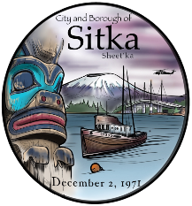


Pattern
Name:
Write sentence or two describing your pattern and color choices:

Crosswalk
Safety
Design Ideas
Entry sheet
Design area

White crosswalk bars

Earth tone
color
palette:

Contact info of designer
Name:
Phone:
Email:

