
June 30, 2025

City Administrator Update

We are looking forward to the SIT Rocky Gutierrez Airport Terminal Addition Open House and Escalator Ribbon Cutting event on Saturday, August 16. We will have more information to share leading up to the event!
As always, our goal is to help Sitka thrive while balancing the opportunities that tourism brings with the everyday life of our residents. We are working hard to support both, and we encourage everyone to stay connected and informed.

Grand Opening - Crescent Harbor Restrooms
Last week we celebrated the grand opening of the brand new Crescent Harbor Restrooms with an official ribbon cutting, featuring none other than a roll of toilet paper to mark the occasion.
Public Works and Administration staff, McG Constructors, Mayor Eisenbeisz, and Assembly Members joined in the flush activities. There will be a few more finishing touches, but the new facility brings improved access and updated amenities to a busy stretch of Sitka's waterfront.
Thank you to everyone who helped bring this project to life for visitors and residents, and to James Poulson for this awesome photo!
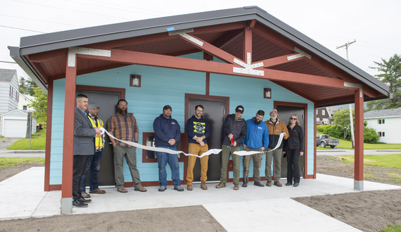

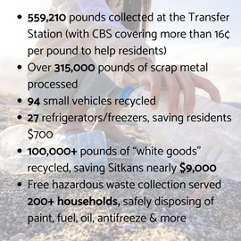
Spring Clean-Up 2025 Stats
In case you missed it: CBS crews and plenty of Sitkans, did some major Spring cleaning over the past couple months.
Check out these incredible stats. BIG thanks to all who supported this effort!
________________________________
Visit www.CityofSitka.com for the latest updates on events, city projects, and opportunities to get involved. There’s plenty of summer fun ahead and I look forward to seeing you all around and about town!

Parks & Recreation Updates: Shaping Up for Summer!
Blatchley Pool Makeover Underway
A major renovation of the Blatchley Pool has been in the works. Crews worked hard on long-overdue maintenance that will keep this community favorite in great shape for years to come. We are THRILLED to share; the pool is open TODAY!
If you’re curious about the project details and want to connect with someone, email Recreation@CityofSitka.org.

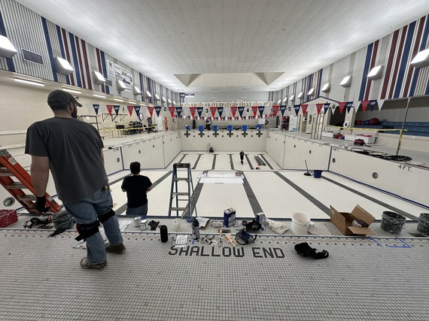

Summer Camp in Sitka
Get ready for six weeks of summer fun! We started June 9, and plan to host 30 kids each week for a classic camp experience! Think field days, arts and crafts, volcanoes, slime (yes, all the SLIME), STEAM activities, and exciting field trips to local favorites like the Sitka Sound Science Center, Alaska State Parks, and Fortress of the Bear. Want to learn more? Email Elle Campbell.

Coming in July: Renewable Energy Camp
We’re teaming up with REAP (Renewable Energy Alaska Project) and Bri Gabel, CBS’s Sustainability Coordinator, to host a one-week Renewable Energy Camp for 4th and 5th graders this July.
Campers will tour Sitka’s hydropower substation and dive into hands-on projects to learn where our electricity comes from. Check out these photos from last year’s solar and wind powered tiny home builds in this edition. Email Elle Campbell to get signed up today! Photo credit to Ryan Morse for those great shots.
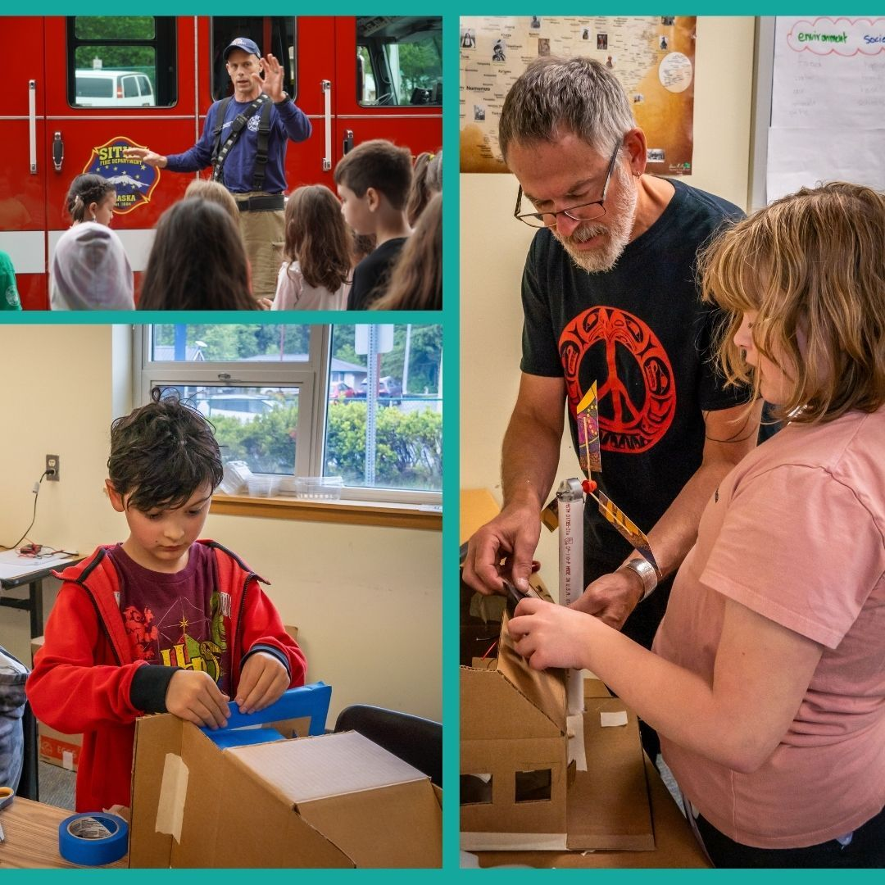

Let’s Talk Tourism
Tourism Updates: Lincoln Street, Restrooms & More
Tourism is on everyone’s mind this summer. After much discussion, Lincoln Street will remain open through the end of this month to monitor traffic and pedestrian flow, and the CBS Assembly will have further discussions on July 8. Additionally, a section of Maksoutoff Street (between Lincoln Street and the Wells Fargo driveway) will be closed through September to allow for temporary restroom facilities.

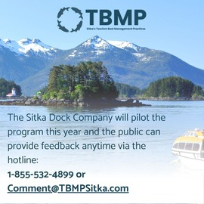
M
Managing Tourism: The Tourism Best Management Practices (TBMP) program launched its 2025 guidelines this spring. This voluntary effort encourages tourism businesses to align with community goals while delivering a great visitor experience.

Special Election Results
For the first time in 21 years, Sitka held a Special Election on May 29, with voters turning out in record numbers to weigh in on the ballot measure related to cruise limits. The results? Ultimately, Sitkan voters rejected the cruise limits.
Please know, moving forward, CBS remains committed to supporting both residents and local businesses so they can thrive during tourism season through programs and partnerships like the Tourism Best Management Practices and the continued recruitment of a dedicated CBS Tourism Manager to help guide and support this important work!
Help Wanted: Pedestrian Safety Attendant
CBS is still seeking seasonal pedestrian safety attendants to help manage foot traffic at the entry and exit of Harrigan Centennial Hall. If you or someone you know would like a fun (and important!) summer job with competitive pay, visit www.CityofSitka.com to apply.

Sitka Happenings

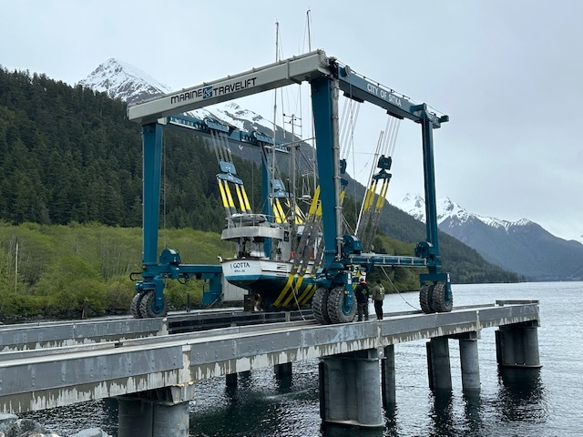
Marine Haul Out: First Boat Hits the Lift
BIG NEWS: The first boat, F/V I Gotta, was successfully hauled out for training at Sitka’s new Marine Haul Out this spring! The operator contract is being finalized, and the facility is expected to open for public use later this summer. Keep an eye out for announcements about the upcoming ribbon-cutting event.
CBS has also applied for $5.77M in federal funding to help support further uplands development at the site and is actively exploring more opportunities to build out this critical waterfront resource for Sitkans and visitors in the marine trades.
Coming Soon: Airport Escalator Ribbon Cutting + Contest
Sitka’s brand-new airport terminal addition is nearly ready and the community’s very first airport escalator will soon be moving people up and down! Although there are several phases of this project left to complete, we want to celebrate this special milestone. A Ribbon Cutting & Terminal Open House is planned for August 16. Stay tuned via our website or social media for more details as we get closer!
For the fun part: Kids (k-5) in Sitka are invited to help mark the occasion by entering the Airport Escalator Essay & Art Contest!
Students can write a short story, draw a picture, or both, on one of these fun topics:
- Why I want to ride the airport escalator first
- How the airport helps our community
- My dream trip
Contest winners will be among the very first to ride the new escalator during the ribbon cutting event!
Entries are due by July 31, 2025. Submissions can be dropped off at: City Hall, 100 Lincoln Street, Sitka, AK 99835, OR emailed to Melissa.Wileman@CityofSitka.org. For more information and a template for the contest, visit: www.cityofsitka.com/news/post/21326/.

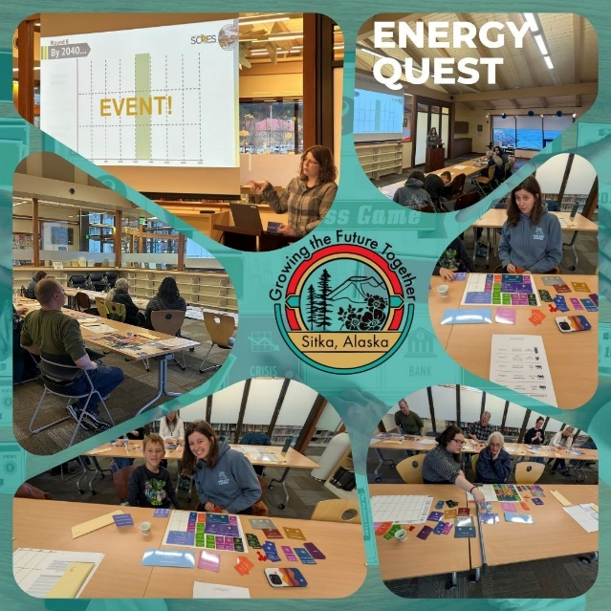

Help Shape Sitka’s Energy Future — In Just 5 Minutes!
The Sitka Community Renewable Energy Strategy (SCRES) team wants to hear from you, and it only takes 5 minutes to complete the Energy Action Survey. You can also share your feedback via our interactive EnergyQuest boardgame too!
Learn more about SCRES and explore Sitka’s renewable energy goals at:
www.CityofSitka.com/SCRES


Mark Your Calendar for Municipal Election Candidate Filing
Candidate filing for Sitka’s October 7 Municipal Election will be opening soon!
The City and Borough of Sitka will hold its next regular municipal election on Tuesday, October 7, 2025. The following seats will be on the ballot:
- Two Assembly Member seats (3-year terms)
- Two School Board Member seats (one 3-year term and one 2-year term)
Candidate filing opens Monday, July 21 at 8:00 a.m. Candidate packets will be available at that time. The deadline to file is Friday, August 8 at 5:00 p.m.
Qualifications:
- Assembly candidates must be qualified voters who have resided continuously in the municipality for 12 months immediately prior to the election.
- School Board candidates must be qualified voters in the municipality for at least 30 days immediately prior to the election.
- For more information, contact the Municipal Clerk’s Office at 907-747-1826 OR 907-747-1811.

Sitka Community Garden in Bloom
On May 17, about 25 community members gathered to celebrate the groundbreaking of Sitka’s new Community Garden-- a big step forward in addressing CBS Strategic Plan Goal 1.5: “Continue to facilitate community partners to address the challenges of food security.”
Located on City-owned land leased through a public RFP process, the site is being designed with a bear-resistant fence, solar power, and both walk-in and drive-in gates to keep deer and bears at bay. Plots will be assigned this winter and will operate as a cooperative model, with shared rules, work hours, and the option for gardeners to build either raised or mounded beds.
Questions? Contact: SitkaCommunityGardens@gmail.com
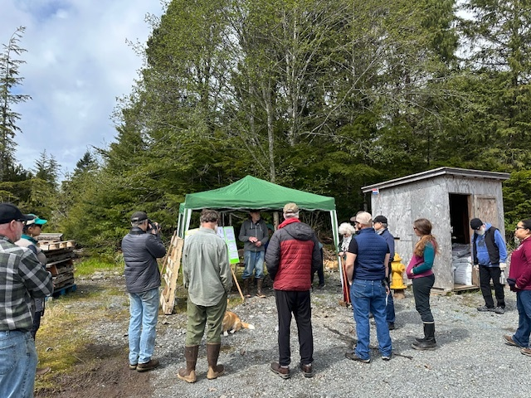

CBS Strategic Plan
All of these exciting projects and programs from recreation programs, energy initiatives, to tourism management and public improvements, are guided by the CBS Strategic Plan. A plan that was shaped by YOU, the Sitka community in 2022. Our strategic plan acts as a compass and it helps our organization stay focused on a set of shared goals, rooted in community priorities and informed by current trends. At CBS, we truly eat, sleep, and breathe the vision our community created. And as we move through year three of this plan, we remain committed to carrying that vision forward and helping Sitka thrive. You can explore the full plan anytime at www.CityofSitka.com.
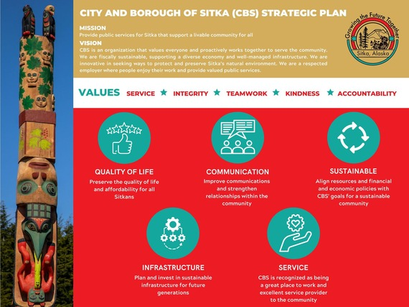

Update your subscriptions, modify your password or e-mail address, or stop subscriptions at any time on your Subscriber Preferences Page. You will need to use your e-mail address to log in. If you have questions or problems with the subscription service, please contact subscriberhelp.govdelivery.com.
This service is provided to you at no charge by City of Sitka.

